**LOSS FUNCTION IN DEEP LEARNING**

* It is a function that maps an event of one or more variables onto a real number representing some cost associated with that event.
* Simply, we can say it is a function which compares the target and predicted output values.
* It measures how well the neural network model is training the data.
* Evaluates how algorithm is modelling the dataset.

There are several loss function types depending on the usage of algorithms.

1. Regression Loss – used in regression neural networks.
2. Mean Squared Error/Squared Loss (l2 loss)

* In this, Take the difference between actual value and predicted value, then square it and then average it across the dataset.
* Formula – MSE= 1/N sigma(range of 1 to N)(Yi -Y1i)^2
* Characteristics – East to interept, only on local minima

1. MEAN ABSOLUTE ERROR (l1 loss)

* In this, Take the difference between actual value and predicted value, then average it across the whole dataset.
* Formula – MAE = 1/N sigma(range of 1 to N)|Yi – Y1i|
* Characteristics – Robust to outlier
* In this, we cannot use gradient descent directly

1. Huber Loss

* Used in robust regression – less sensitive to outliers in the data.

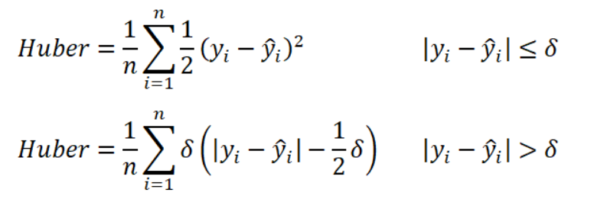

Delta – defines huber loss function transitions from quadratic to linear.

* It lies between MAE and MSE
* It is more complex. for the optimization of delta- we need more training requirements.

1. Classification Loss
2. Binary Cross Entropy (log loss)

* Compares each of the probability class to the actual output.
* Calculates scores based on the distance from expected value

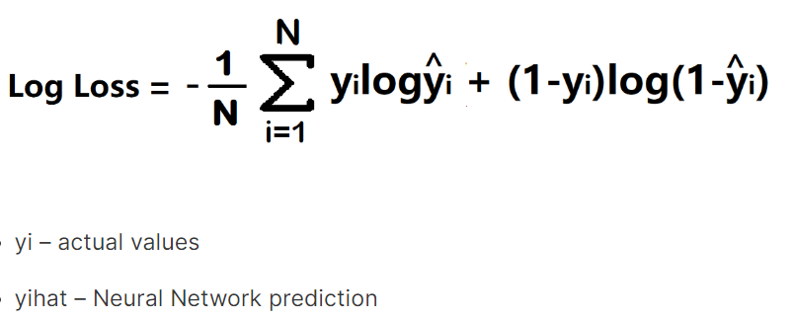

* It is a differential function.
* It has multiple local minima that will be a disadvantage

1. Categorical Cross Entropy

* Used for Multiclass Classification and softmax regression.

